+

NETWORKING AND SECURITY PRACTICES
COURSEWORK 1
PART A
NILOOFAR THAHA
STUDENT ID : THA21540701
3-4-2023

The planned network would be a wide-area network (WAN) that links the cybersecurity consultancy firm's branch offices in Scotland, Ireland, Wales, and York with its London headquarters. The network will be developed to provide safe data transfer and communication across the offices, enabling staff to cooperate and share information instantly. The network will be built with redundancy and fault tolerance in mind, preventing a system outage in the event that one of its components fails.
Architecture and Usability: The suggested network would employ a hub-and-spoke architecture, with the London office serving as the hub and the branch offices as the spokes.A dedicated Virtual Private Network (VPN) link will connect each branch office to the London office, enabling secure communication between the offices. Firewalls and intrusion detection systems will also be installed on the network to guard against hacker assaults and prevent unwanted access. In order to maintain network efficiency, the network will also feature Quality of Service (QoS) protocols to give crucial data traffic priority over less important traffic.
Topology and hardware requirements:
The planned network will need routers, switches, firewalls, and VPN gateways as part of its hardware needs. The London office will act as the hub and the branch offices as the spokes in a hub-and-spoke architecture.
Packet Tracer Design by Cisco:

The following is an example network architecture using Cisco Packet Tracer:Network Protocols: To ensure safe and effective communication, modern networks employ a number of protocols. Transmission Control Protocol/Internet Protocol (TCP/IP), Border Gateway Protocol (BGP), and Dynamic Host Configuration Protocol are examples of common network protocols (DHCP). The main internet protocol for data transmission is TCP/IP, whereas BGP is used to route traffic across various networks. Devices on a network receive IP addresses automatically thanks to DHCP.
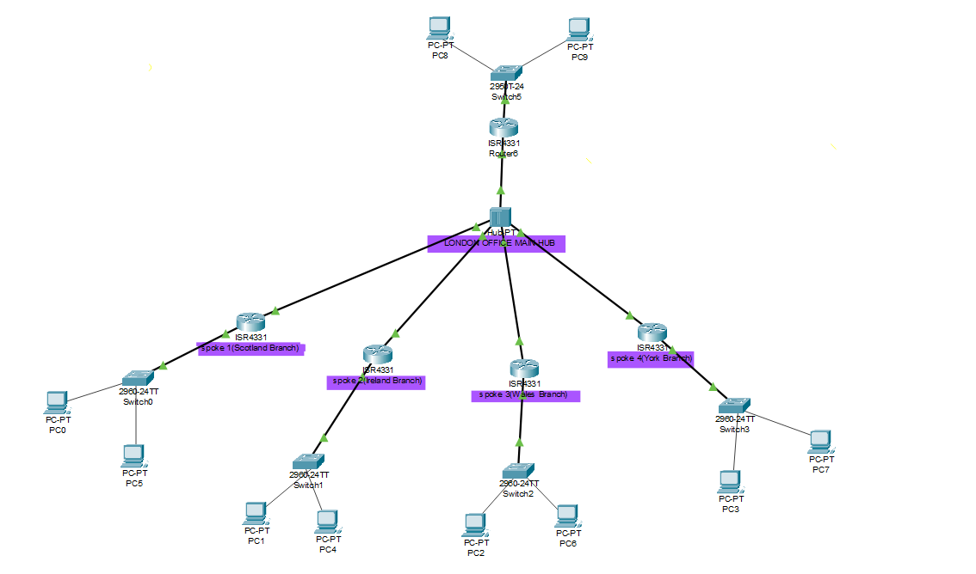

Network Security: While building up a network, adequate network security understanding is crucial. Network integrity can be jeopardised and private information can be accessed without authorization if a network is not adequately secured. To stop illegal access to the network, firewalls, intrusion detection systems, and other security measures are crucial.Hardware Security: While setting up a network, hardware security is also a crucial factor to take into account. To prevent unwanted access to network equipment, hardware security measures might include password protection, encryption, and physical security measures.

Difficulties and Mitigating Strategies: Bandwidth restrictions, hardware malfunctions, and cyberattacks are the three key variables that might pose problems for the suggested network design. The network can be set up to prioritise vital data traffic and utilise caching and compression technologies to minimise the quantity of data transmitted across the network in order to overcome bandwidth restrictions. Redundancy and fault tolerance can be included into the network architecture, together with backup components and failover procedures, to reduce the impact of hardware failure. Employees may be educated to recognise and prevent phishing efforts and other sorts of cyber assaults, and the network can be constructed with firewalls and intrusion detection systems to combat cyber attacks.

Network Protocols:
Modern networks use a variety of protocols to ensure secure and efficient communication. Some common network protocols include Transmission Control Protocol/Internet Protocol (TCP/IP), Border Gateway Protocol (BGP), and Dynamic Host Configuration Protocol (DHCP). TCP/IP is the primary protocol used for transmitting data over the internet, while BGP is used for routing traffic between different networks. DHCP is used to automatically assign IP addresses to devices on a network.

Network Security:
Adequate network security knowledge is essential while setting up a network. Failure to properly secure a network can result in unauthorized access to confidential information and can compromise the integrity of the entire network. It is essential to use firewalls, intrusion detection systems, and other security measures to prevent unauthorized access to the network.

Hardware Security:
Hardware security is also an essential consideration when setting up a network. Hardware security measures can include password protection, encryption, and physical security measures to prevent unauthorized access to network devices.

